Intro to Comm and Media: Lecture Notes Prof. Garlic, Fall 2024

# August 21, 2024 (Wednesday)

## Schedule for Today

* Update on Canvas
* Chapter 1 Textbook Overview
* Meet with Me

### Update on Canvas

The Canvas site is live and will be updated with the survey and room number for my office hours.

### Chapter 1 Textbook Overview

* Marshall McLuhan - *The Medium is the Message*
  + Bio <https://www.marshallmcluhan.com/biography/>
  + Video in Textbook
* Definitions
  + mass
  + medium / media
  + culture
    - shared values, attitudes, beliefs, and practices of a social group, organization, or institution
  + pop culture
    - media, products, and attitudes considered to be part of the everyday life for the mainstream of a given culture
* Historical perspective of mass media
  + <https://prezi.com/-ibd5ojx6ssd/historical-perspective-of-mass-media/>

# August 26, 2024 (Monday)

## Schedule for Today

* Review of Survey Results
* Newspaper Announcement
* Chapter 1 Textbook Overview (contd.)
* Media Effects Activity

### Review of Survey Results

* Tech brought to class
  + 88% laptops
  + 12% mobile phones

### Chapter 1 Textbook Overview (contd.)

* Convergence
  + Distinct technologies –> sharing of content, tasks, and resources
    - Examples?
  + Niche communication relics
    - Polaroid cameras
    - 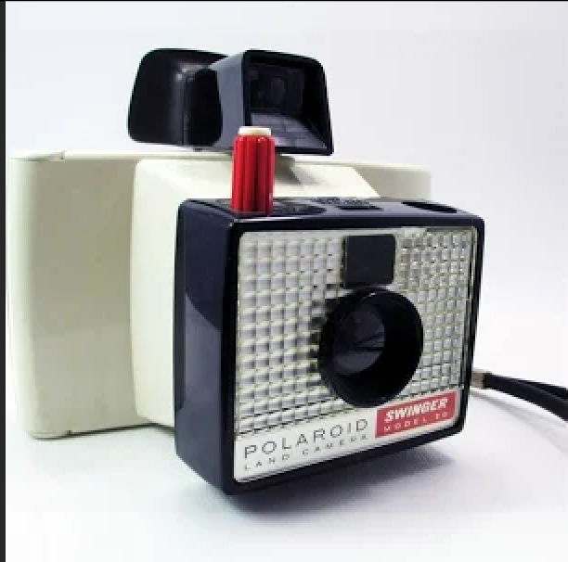
    - Polaroid camera circa 1980s
    - new Polaroid
    - 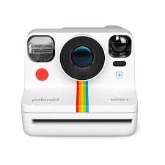
    - Polaroid camera circa 2020s
  + Individuals - passive consumption to multitasking
    - Harmful or maybe not?
* Shaping Culture
  + tastemakers / influencers - introducing new ideas, music, videos, products
  + gatekeepers - what becomes public
* Media Literacy
  + Five Key Questions of Media Literacy <https://www.medialit.org/sites/default/files/14B_CCKQPoster+5essays.pdf>

### Media Effects Activity

* How does media shape individual beliefs and behavior?
* Consider media form (“media is the massage”) and content.

# August 28, 2024 (Wednesday)

## Schedule for Today

* Listening to Textbook Illustration (iPad/iPhone)
* WPHU Radio Announcement
* Media Effects Activity Review
* Chapter 2 Textbook Overview
* Student Media Clips Example

### Listening to Textbook

* Voiceover <https://www.apple.com/accessibility/iphone/index.html#:~:text=VoiceOver%20is%20a%20revolutionary%20screen,with%20every%20built%E2%80%91in%20app.>

### Chapter 2 Textbook Overview

#### Media Effects

##### What is a theory? *Idea(s) about why or how something happens.*

##### Media Effects Theories

* How media affects us
  + Direct Effects
  + Two-Step Flow
  + Agenda Setting
  + Spiral of Silence
  + Cultivation Analysis (Mean World Syndrome)
* Why we are drawn to certain types of media
  + Uses and Gratifications
* How we interpret media
  + Symbolic Interaction
  + Media Logic

#### Media Messages

* Objectivity and Bias in News
* Propaganda and Persuasion in Politics
* Stereotypes
* Black Women in Media <https://www.youtube.com/watch?v=2teqoyPe3TU>
* Consumerism
* Visual Analysis
* Top Fashion Trends <https://www.youtube.com/watch?v=m0IPlbYnLf8>
  + How many references to consumerism do you notice?
  + What other positive or negative effects might there be?

### Student Media Clips

# September 3, 2024 (Wednesday)

## Schedule for Today

* Research as Art Competition ($250 cash prize)
* Quiz Comments
* Student Media Clips
* Books
* Next Quiz and SMC Reminder

### Research as Art Competition

[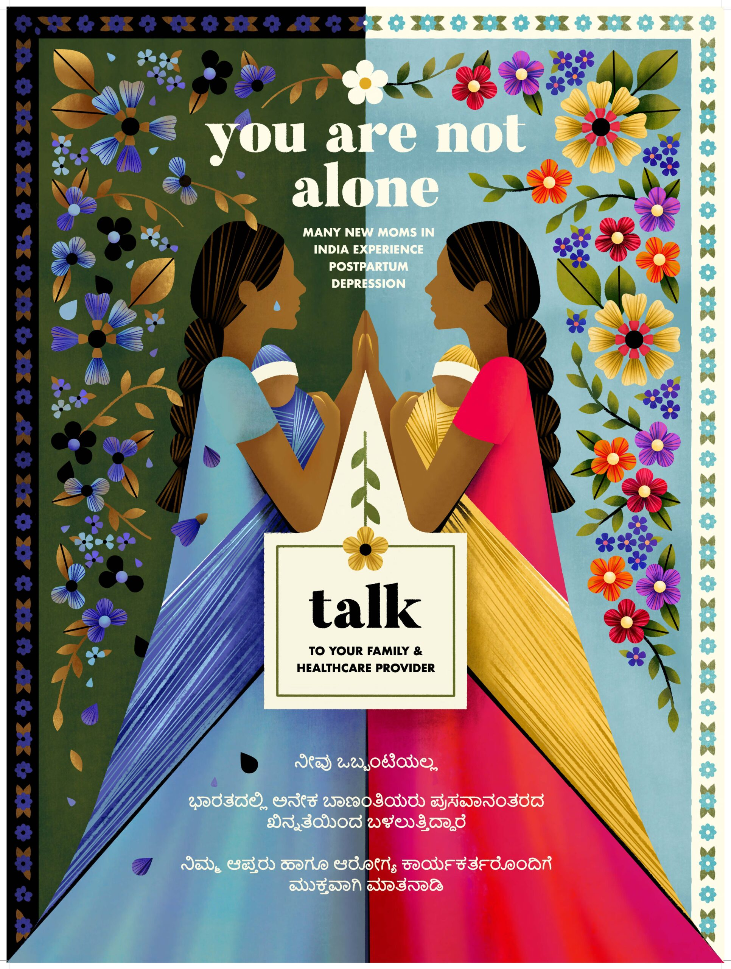](https://nexus.jefferson.edu/science-and-technology/you-are-not-alone-an-interdisciplinary-effort-to-tackle-postpartum-depression/)

* Submit here: <https://jefferson.co1.qualtrics.com/jfe/form/SV_2gY6DXezMy8xwou>
* Deadline October 4, 2024

### Student Media Clips

#### Media stereotypes (Adriana)

Mean Girls too gay

<https://www.youtube.com/watch?v=bSmULnvv-Ig>

#### Two-Step flow media effects (Sean)

Blake Griffin dunks

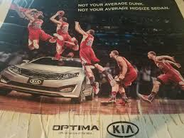

#### Direct effects 💉 (Kaci)

Peacock show trailer

lcvelslandd

<https://www.tiktok.com/@lcvelslandd/video/7401569226743500075?_r=1&_t=8pHFQHGNI34>

* Passive or active acceptance?

### Books

Who reads/doesn’t read books now?

[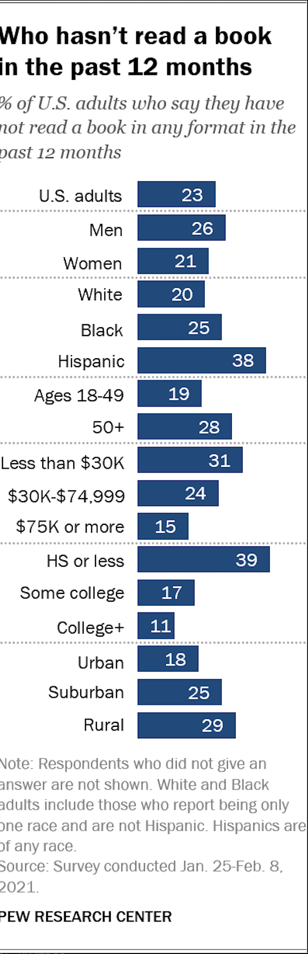](https://www.pewresearch.org/short-reads/2021/09/21/who-doesnt-read-books-in-america/ft_2021-09-21_nonbookreaders_01-png/)

<https://www.pewresearch.org/short-reads/2021/09/21/who-doesnt-read-books-in-america/ft_2021-09-21_nonbookreaders_01-png/>

#### History of books

Egyptian papyrus

[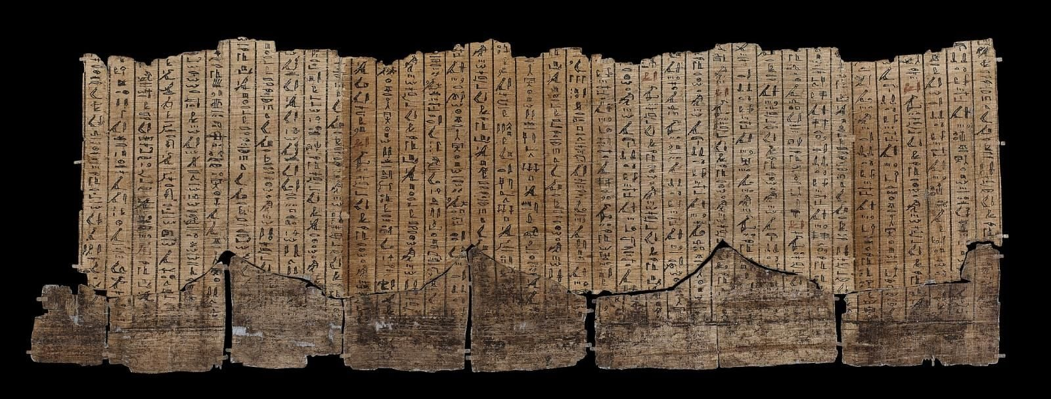](https://www.britishmuseum.org/blog/preserving-papyrus-caring-4000-year-old-documents)

<https://www.britishmuseum.org/blog/preserving-papyrus-caring-4000-year-old-documents>

Early Buddist Texts

[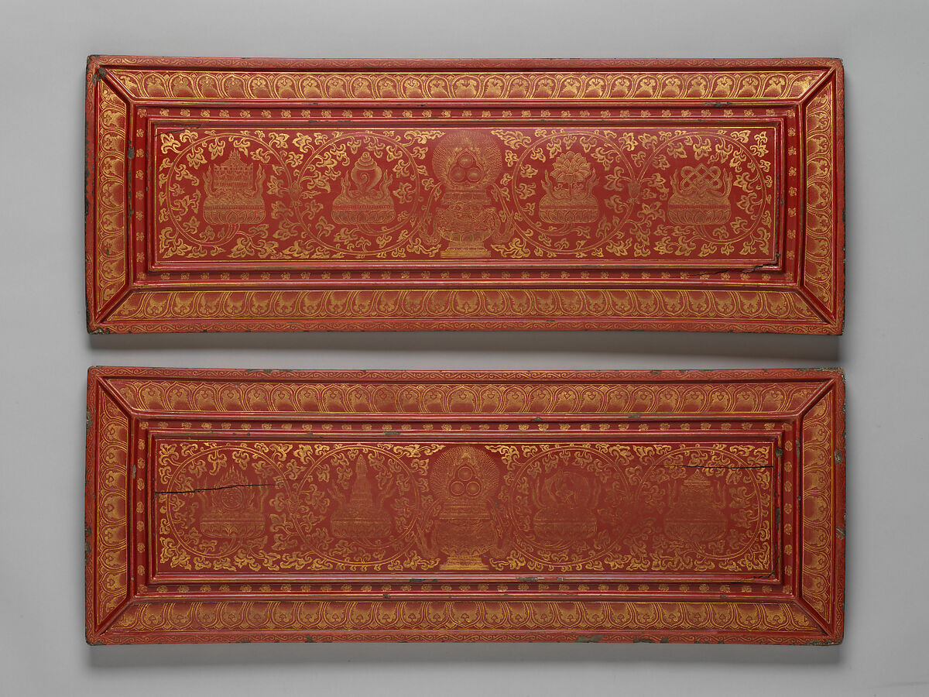](https://www.metmuseum.org/art/collection/search/40250)

<https://www.metmuseum.org/art/collection/search/40250>

The Codex and Beyond

[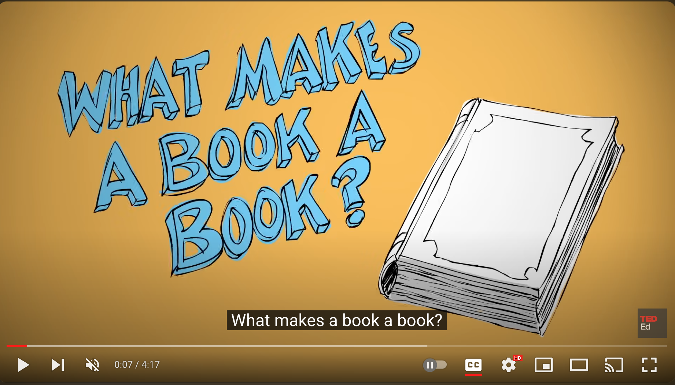](https://www.youtube.com/watch?v=_YqYtdPUis4)

<https://www.youtube.com/watch?v=_YqYtdPUis4>

### Books Affecting Culture

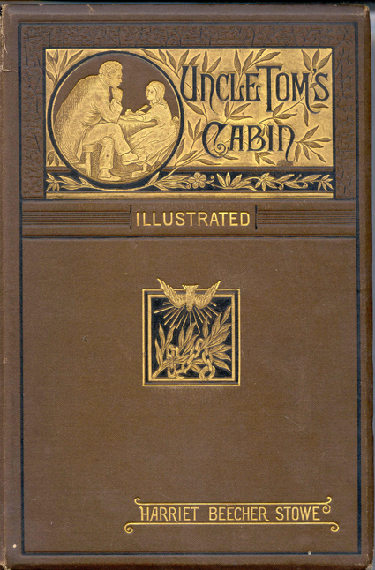

<https://www.harrietbeecherstowecenter.org/harriet-beecher-stowe/uncle-toms-cabin/>

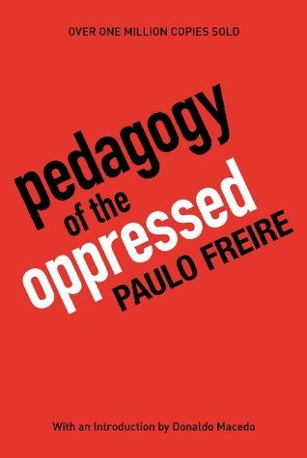

<https://www.goodreads.com/book/show/72657.Pedagogy_of_the_Oppressed>



<https://www.amazon.co.uk/Girl-Dragon-Tattoo-Millennium-Book-ebook/dp/B00480O9L4/ref=sr_1_2?crid=1ZF7AI6ZS58VK&keywords=The+Girl+With+The+Dragon+Tattoo&qid=1655221570&s=books&sprefix=the+girl+with+the+dragon+tattoo+%2Cstripbooks%2C133&sr=1-2>

### Copyright and Fair Use

#### History

* Statute of Queen Ann (1710) - 14 years exclusive rights to book publishers
* U.S. Constitution Statutes

|  |
| --- |
| * Article I, Section 8, Clause 8: |
| “[The Congress shall have Power . . . ] To promote the Progress of Science and useful Arts, by securing for limited Times to Authors and Inventors the exclusive Right to their respective Writings and Discoveries.” |

<https://constitution.congress.gov/browse/essay/artI-S8-C8-1/ALDE_00013060/>

* Statutes, e.g., Copyright Law of 1790

#### Basic Definitions

*Copyright:* Exclusive right to copy, distribute, and adapt

*Public Domain:* public property (expired copyright or never covered0

*Fair Use*

* criticism
* commentary
* news
* teaching
* research/scholarship

#### Fair Use Learning Activity

<https://www.arl.org/know-your-copyrights/>

* Groups of 3
* Click on 3 sections you find interesting

# September 9, 2024 (Monday)

## Schedule for Today

* Weekly Assignment Due Dates
* Student Media Clips
* Books (contd.)
* Newspapers

### Weekly Assignment Due Dates

Quizzes and SMCs now due by Sunday night each week

### Student Media Clips

Public Domain illustration

* film compilation (Joana)
* 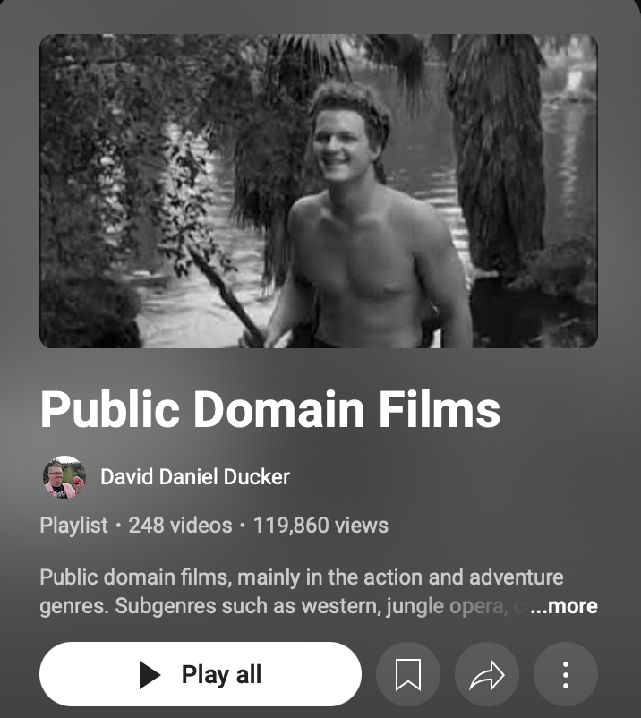
* https://www.youtube.com/playlist?list=PLTYZuvjJPVnGYlXEiFujZFQNk6WMIp6u7

Works that recently entered the public domain

* <https://blogs.loc.gov/copyright/2024/01/lifecycle-of-copyright-1928-works-in-the-public-domain/>

Other sources for finding public domain materials

* <https://www.hathitrust.org>

E-books

* Before the Coffee Gets Cold (Sanjay)

[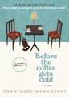](https://www.amazon.com/Before-Coffee-Gets-Cold-Novel/dp/1335430997)

[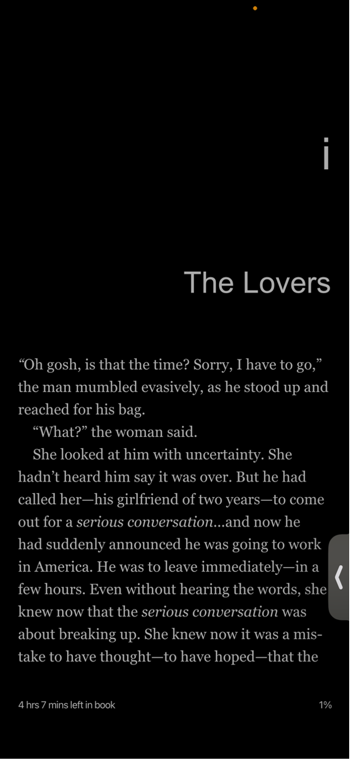]

### Book Formats

* Hardback
* Paperback
* E-books
* Audiobooks
* Differences / similarities / What would McLuhan say?

### Newspapers

* Overview
* American Experience: Citizen Hearst

[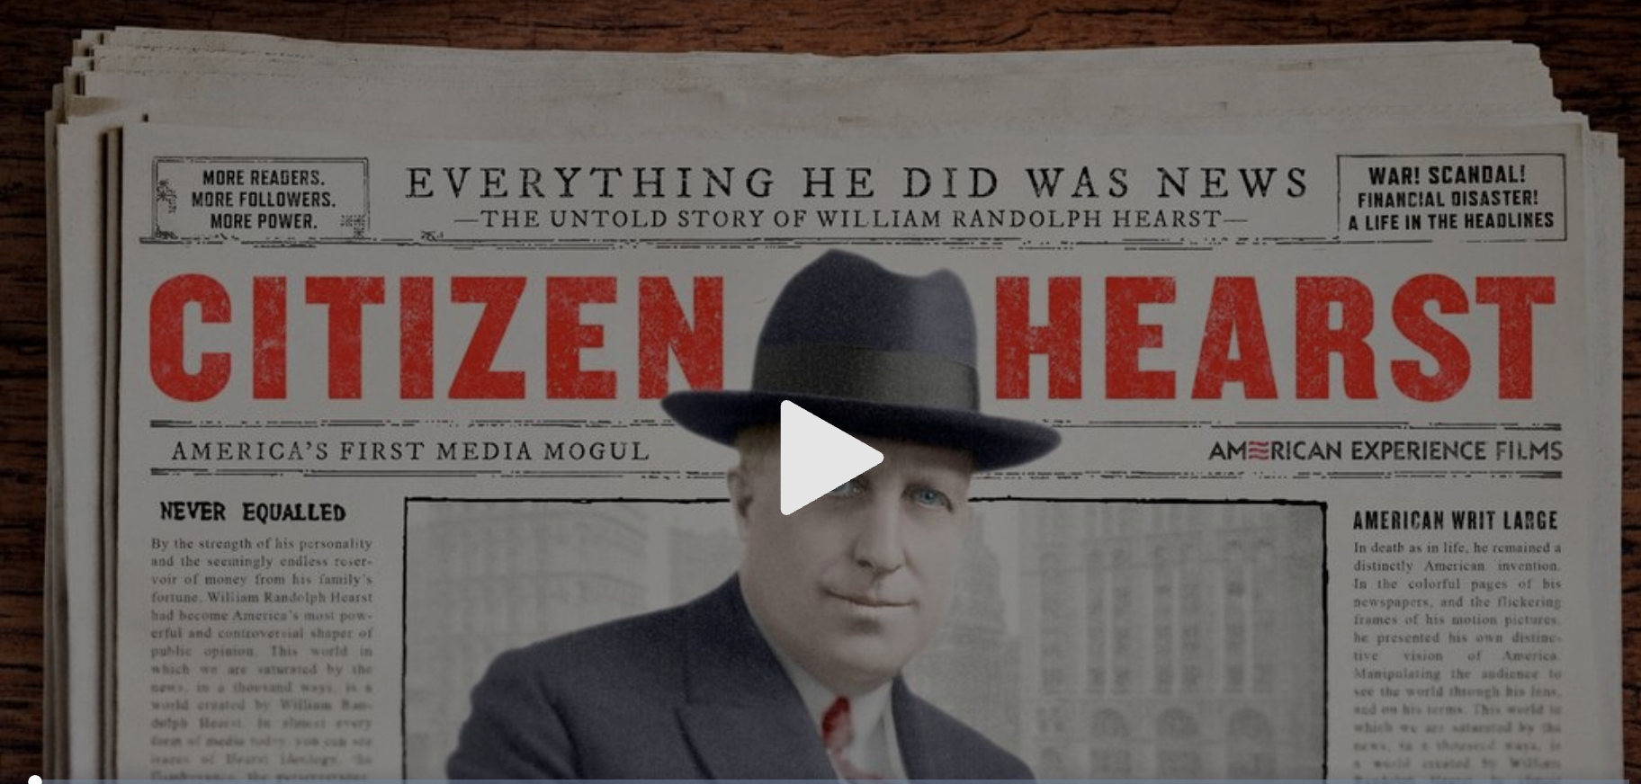](https://www.pbs.org/wgbh/americanexperience/films/citizen-hearst/#part01)

<https://www.pbs.org/wgbh/americanexperience/films/citizen-hearst/#part01>

# September 16, 2024 (Monday)

## Schedule for Today

* Newspapers Recap
* Student Media Clips
* Magazines

### Newspapers Recap

* What stood out to you from Hearst’s life?
* Where are newspapers going?

### Student Media Clips

* Lady and the Trump (Jonathan)

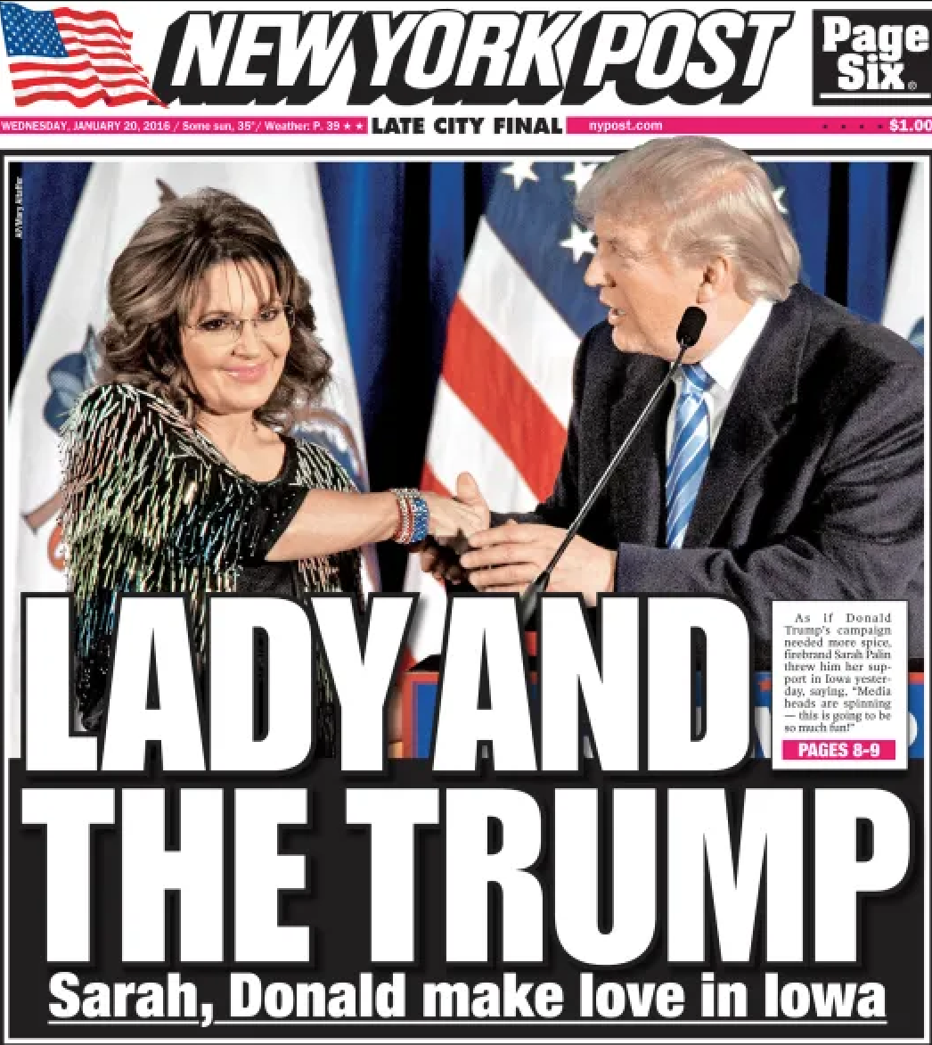

* Jersey Evening Post (Emily)

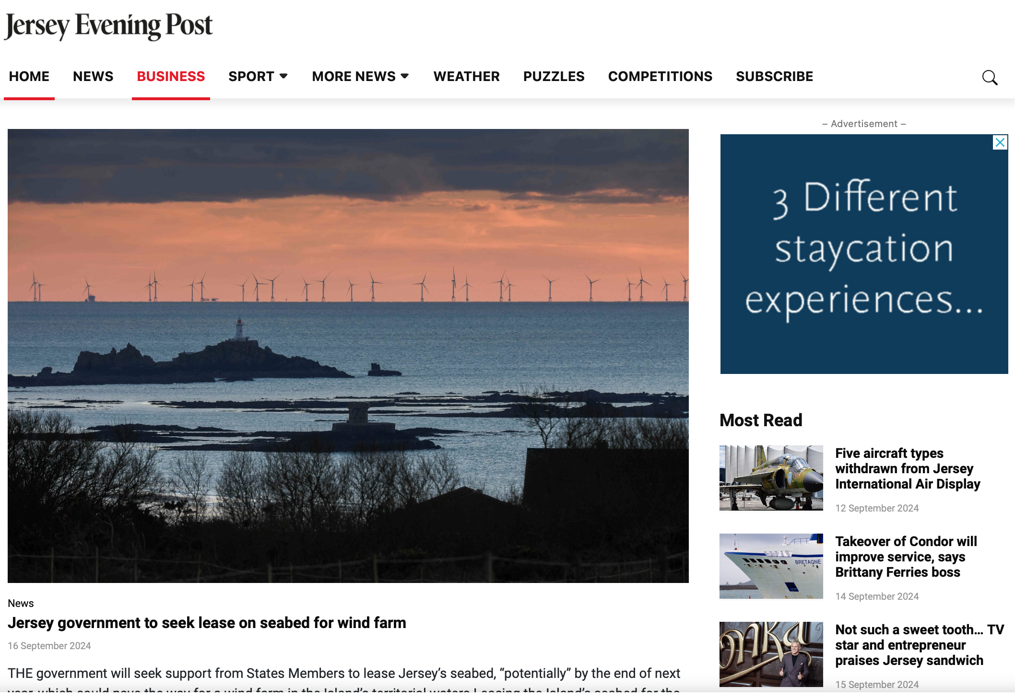

<https://jerseyeveningpost.com>

### Magazines

#### History

* Early history

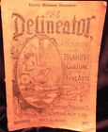

The Delineator - Fashion Magazine

<https://www.ebay.com/itm/305655624808?itmmeta=01J7XW9E73ZCS4T6271EC5M10C&hash=item472a7eb468:g:h80AAOSw6A9mhujG&amdata=enc%3AAQAJAAAAwMxmj%2BiGvOveHXEBClPb29jddVF7kHtaL2KUF0nta1MTiydsEkFlJn36DPtftCS9djOcffDGl9vdteQ8G2armqLuGo7e8TyePFXbeeKQ5Jax%2BdXeJI4yQL9SG2Il0CV3kSblE7X%2Fob2GmvQ7zOtBGJewJal2%2BDIT%2BGyFMwke2UlMSauSeIrPNDO4Fp7djHmJ7IA%2BPhRCpA4ZO6VabeToEwb8ixo0LdMSmDbtmCYjS8TggJw2jwWK1yZx2zNVl6MOcg%3D%3D%7Ctkp%3ABk9SR87jpby_ZA>

* Batman comics
* <https://www.dc.com/blog/2019/03/19/batman-a-history-of-heroics-the-beginning>

#### Businessweek Example

* Businessweek 1929 Cover
* 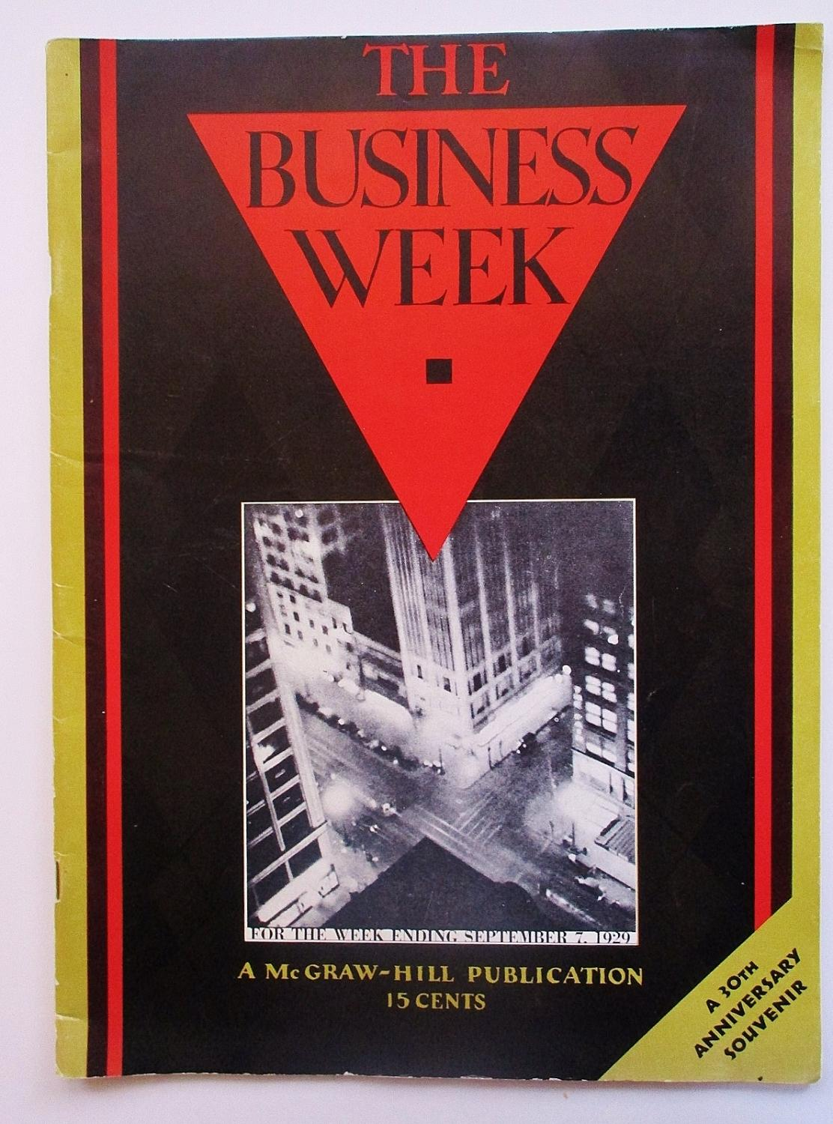

|  |
| --- |
| “The Business Week always has a point of view, and usually a strong opinion, both of which it does not hesitate to express. And all the way through, we hope you will discover it is possible to write sanely and intelligently of business without being pompous or ponderous.” |
| *Malcolm Muir, McGraw Hill (publisher)* |

* Businessweek 1989 Cover - Gambling in Indian Casinos

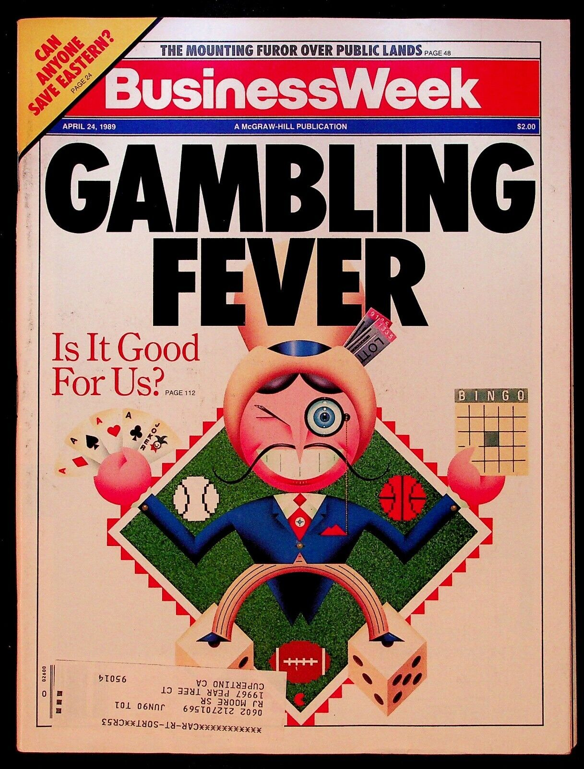

* Businessweek 2014 Cover - Ebola Virus



* Role of advertising
* Magazines geared towards youth in the 80s and 90s
  + Tiger Beat Magazine
  + <https://www.ebay.com/itm/364975252947?_skw=tiger+beat+magazine+80s&itmmeta=01J7XWR94VA8BN0B77YRDQYVBR&hash=item54fa3865d3:g:JZgAAOSwKG5mfhbW&itmprp=enc%3AAQAJAAAA8HoV3kP08IDx%2BKZ9MfhVJKlHwXdFfPDkF4nLpVYq%2BnwcKsbmXVFvPEx5eR00Wo43s8QHUZOg3JuNv5i31Gv2otog%2FvUPTIFR1OX0OHNbQFGKcqNU2RQagZfM8W%2FXJ61GNoc5Q3NUhcR49Rawc5X%2BXdnP%2FqTraMPcDy7kWUT9jJo5pNxpXrl5eNbu6xsNlVZLrhOBYLyYIsYlvwDpQBhxI8d%2F1Gqhg9DNagjaseZfjKEozzPCvjynTsJJoarJmoEpfxp0wciVQs5wepWvZjh0%2F5TLDDdPQZkqvuv9M4tv2KuuvsGKp5r3f1KkGEonG1JtxA%3D%3D%7Ctkp%3ABk9SR76S4by_ZA>
  + Right On Magazine
* <https://www.ebay.com/itm/356029603261?_skw=right+on+magazine&itmmeta=01J7XWNY326JHGRG7GH1BW4DQW&hash=item52e5049dbd:g:~KsAAOSw4Upmw7J9&amdata=enc%3AAQAJAAAA8Mxmj%2BiGvOveHXEBClPb29iqsQ9BAfpw1UENtkXMrO4Zp4QSE3Prhe5L9I1on5Lv7vnZ4TeVAWfaTeQdsQEWersxjTyCfy4tAQYDU1NJSXEdc266Z0hwdd3Hvq052YIVtO5Sy%2BTOHuR194PeTkEcXzfruzikW0pksOM%2F0IupQvCLfdymabyS3rr5%2BsQt34lxVaqUY9D0lK4l0mJc1zGtfUul%2FMfoFE6g0qq7bQg%2FhbikbujXdvev7RHrVDMOhMzkTSvNz5LjUArS--z3hEG8gfOd1coA%2FqczkH16hCVtcdbyGV%2BzsoA8CRWqdVIWzcx%2FPQ%3D%3D%7Ctkp%3ABk9SR8zh17y_ZA>
* Current day magazines - where are magazines going? print . . . online . . .

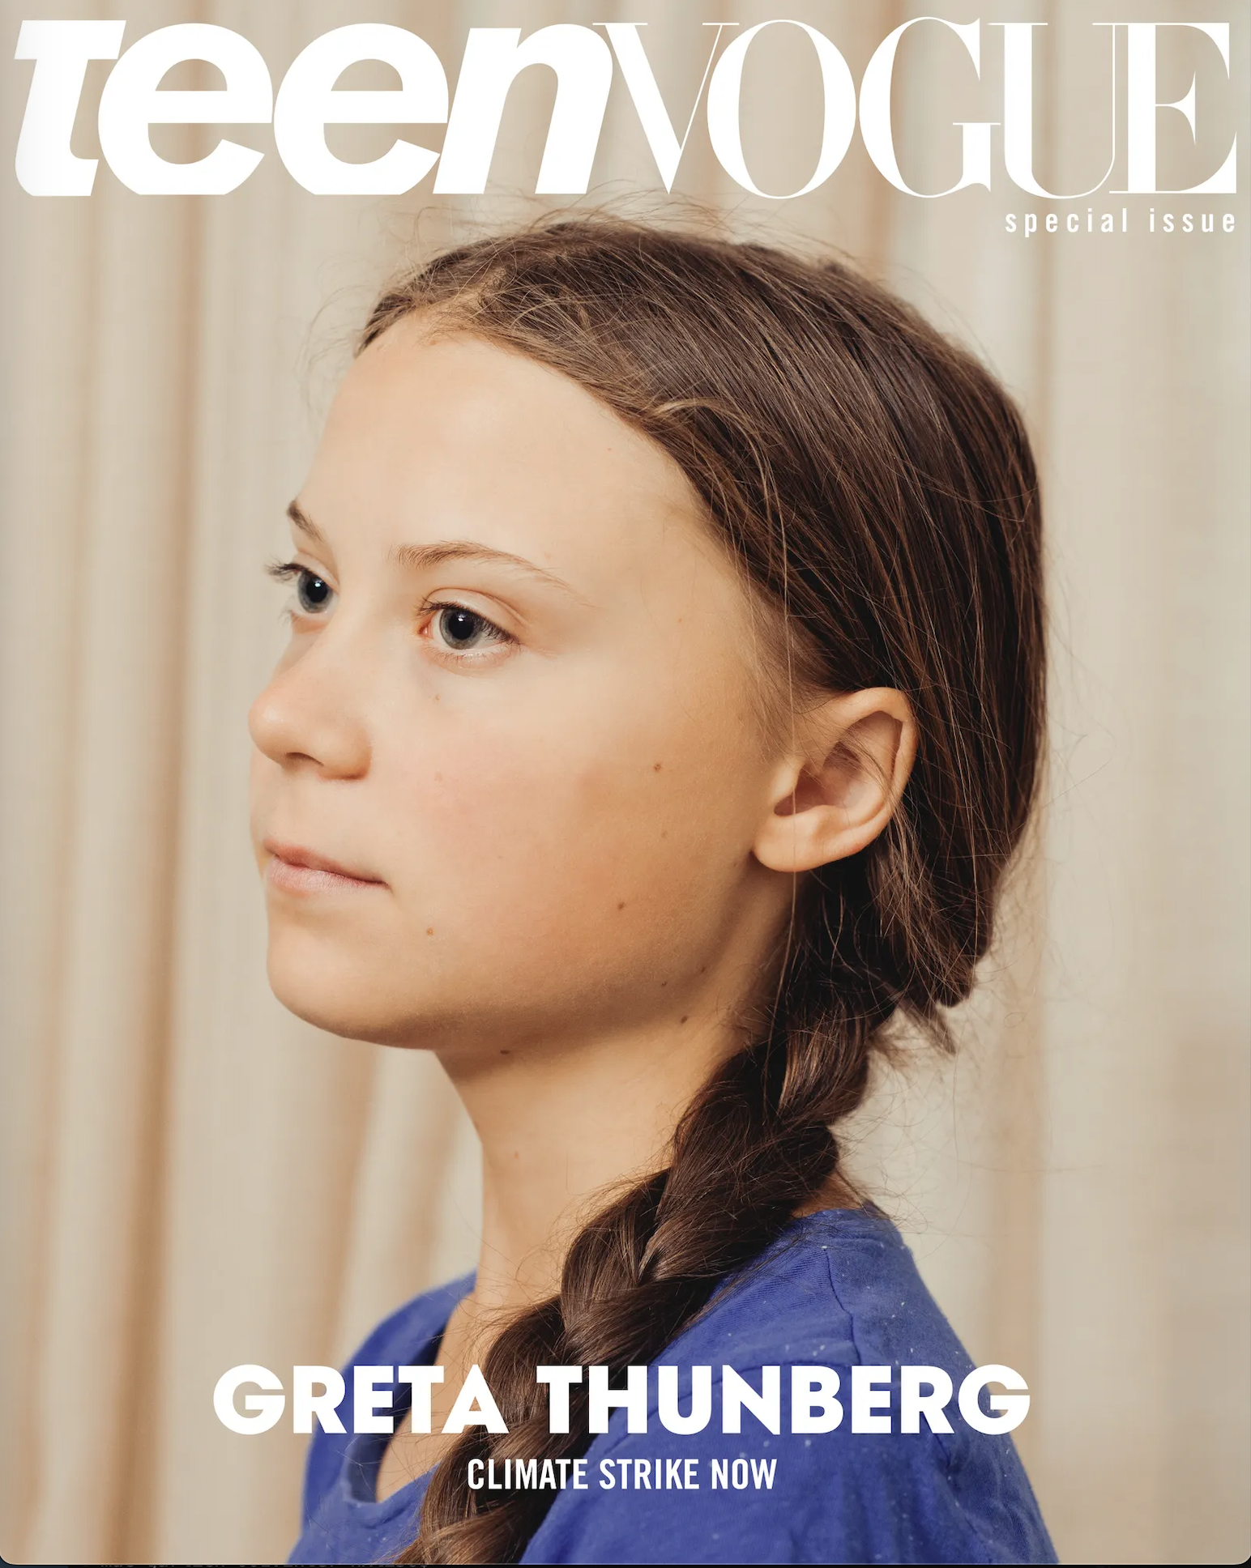

<https://www.teenvogue.com/story/greta-thunberg-climate-strike-teen-vogue-special-issue-cover>

* Class project - editorialize a magazine
  + potential subjects: sports, fashion, news, finance, celebrity, relationships . . .
  + Select from:
    - news articles
    - short fiction
    - poetry
    - advertising
  + Format
    - print
    - online
    - both

# September 18, 2024 (Wednesday)

## Schedule for Today

* Quiz Review
* Magazines (contd.)
* Final Media Project

### Quiz Review

* negative v. positive newspaper examples
  + Center for Integrity in News Reporting
  + 
  + <https://www.cfinr.org/awards>
* media bias: <https://www.allsides.com/media-bias>
  + Guardian example
  + <https://www.allsides.com/news-source/guardian>
* economic interests
  + non-profit news
  + 
  + logo for spotlight news
  + <https://www.spotlightpa.org/about/>

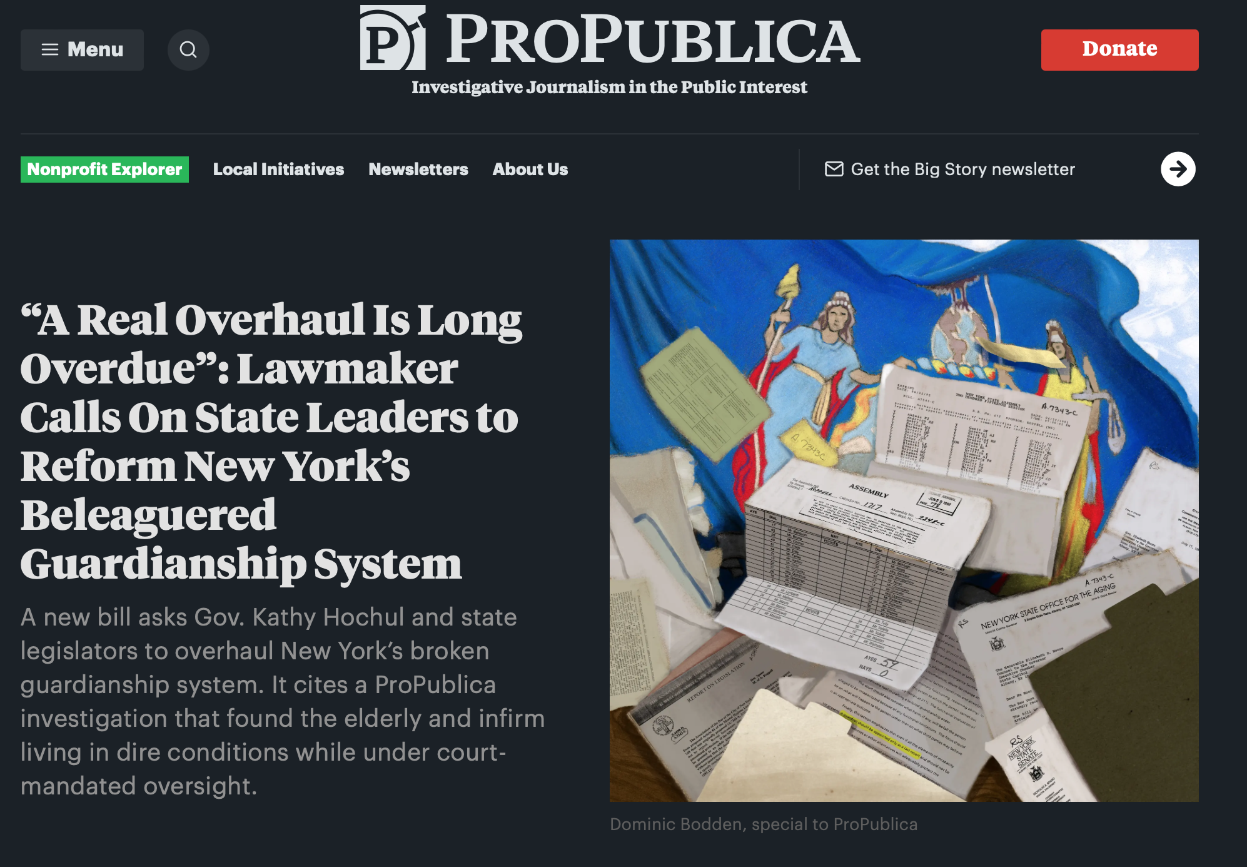

<https://www.propublica.org/article/new-york-city-guardianship-oversight-reform-hochul>

* Russian News on YouTube

<https://www.youtube.com/hashtag/rtnews>

### Magazines

* Editorialize a magazine class project report out - use whiteboards
* Speciality Publications
  + Professional Trade Publications
    - Backstage
    - 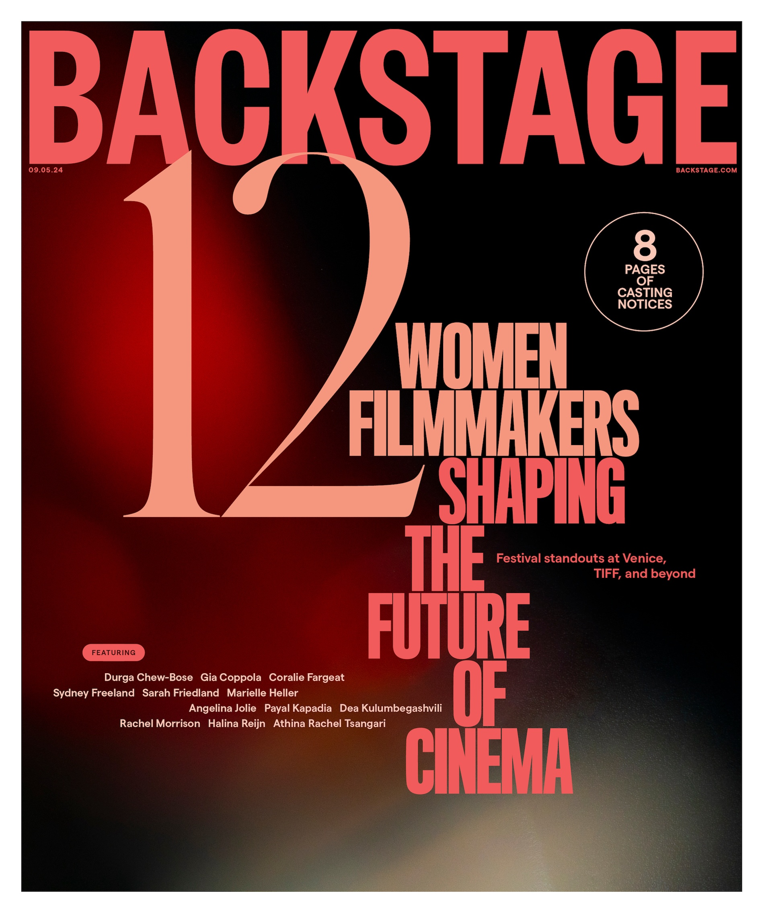
  + <https://www.backstage.com/>
  + Scholarly Journals
    - Journal of Communication
  + Religious Magazines
    - Christian Science Monitor
  + Political
    - The American Conservative
  + Hobbies / Special Interests
    - Architectural Digest
    - 
    - <https://www.architecturaldigest.com/>
* Comic Books
  + Rise of Comic Book Culture
  + <https://www.youtube.com/watch?v=LlFIDuc07ok>

### Final Media Project Overview

* Module - Final Media Project - Final Media Project

# September 23, 2024 (Monday)

### Schedule for Today

* Quiz Review
* Student Media Clips
* Music
* Research Logs - In-class practice

### Quiz Review

* Newspaper v. magazine advertisements
  + The Globe newspaper example
  + <https://globemediagroup.ca/newspaper-advertising-specifications/>
  + Cosmopolitan
  + <https://advertising.hearstmagazines.com/brands/cosmopolitan>

### Student Media Clips

Pulp (Story-based) Magazine (Stella)



Images of Women (Aliya)

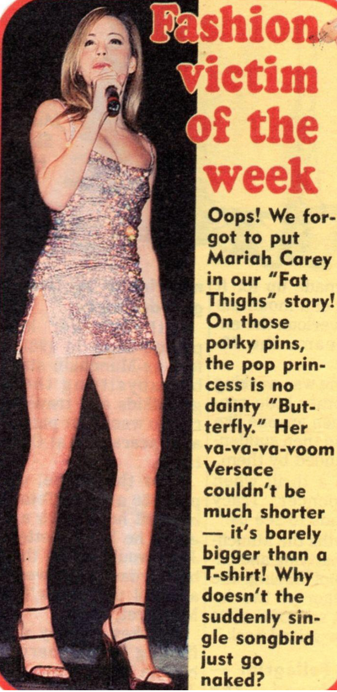

### Music

#### U.S. Music History

*History of American Music -* Interactive journalism

* <https://www.telegraph.co.uk/travel/discover-america/evolution-of-music/>
  + Mamie Smith early jazz recording
  + 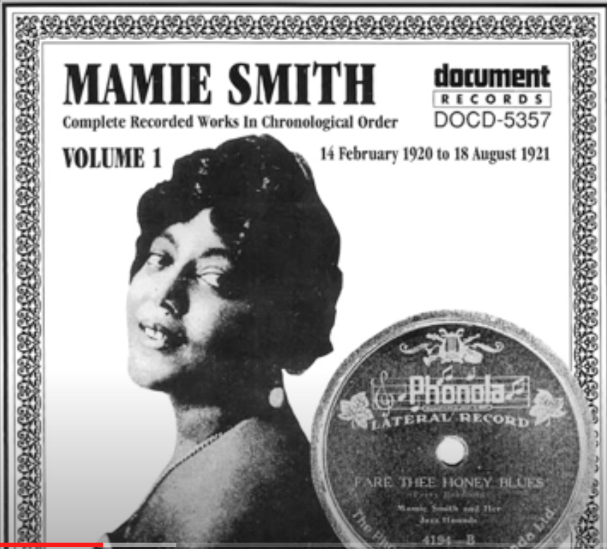
  + <https://www.youtube.com/watch?v=UB-7TFdHRkA>
* Timeline and Genre Activity
  + What are some of your favorite genres?
  + Where do they fit in the timeline?

#### Music Affecting Culture

*Muscle Shoals* Documentary

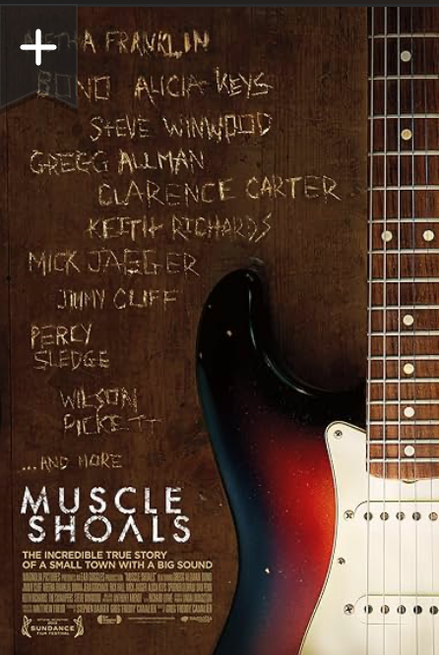

<https://www.youtube.com/watch?v=hKmGUIM1uAI> (5:48 to 29:42)

* Modern day examples?

#### Music, Recording Technology, and Distribution

* From recording studios to streaming . . .

### Research Logs

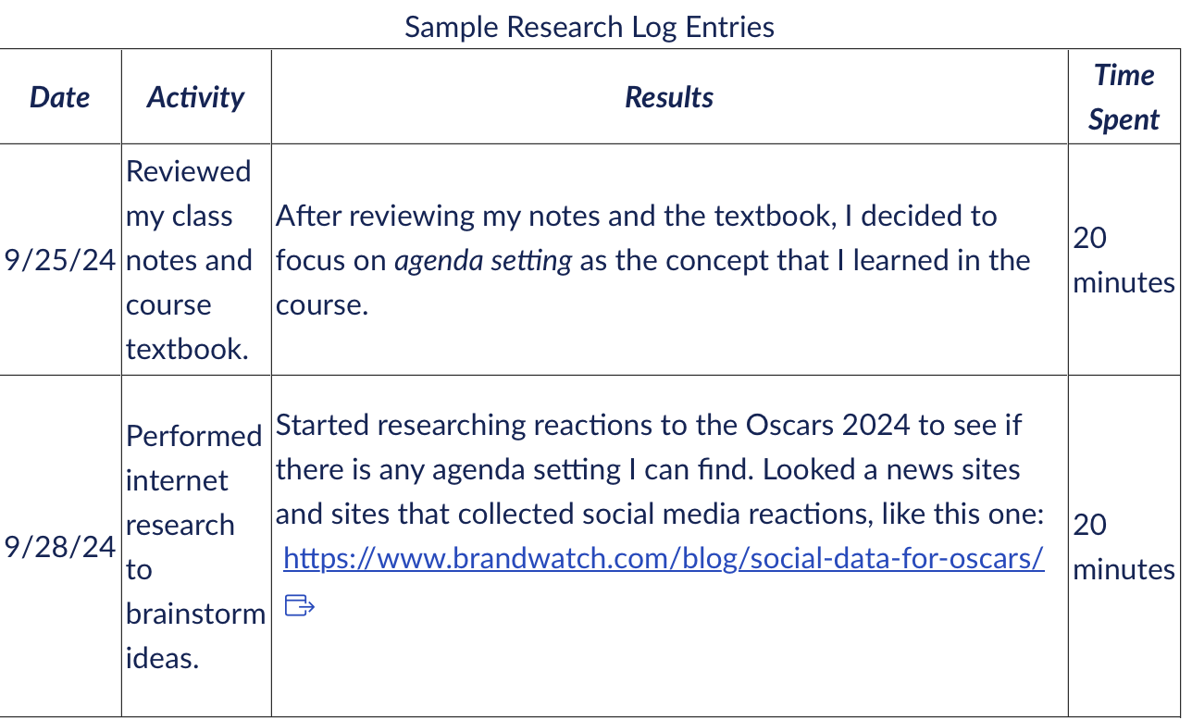

* Communication / media concept?
* Media project type?

# September 25, 2024 (Wednesday)

### Schedule for Today

* Career Fair
* Music (contd.)
* Skill of the Week
* Research Logs - In-class practice

### Career Fair

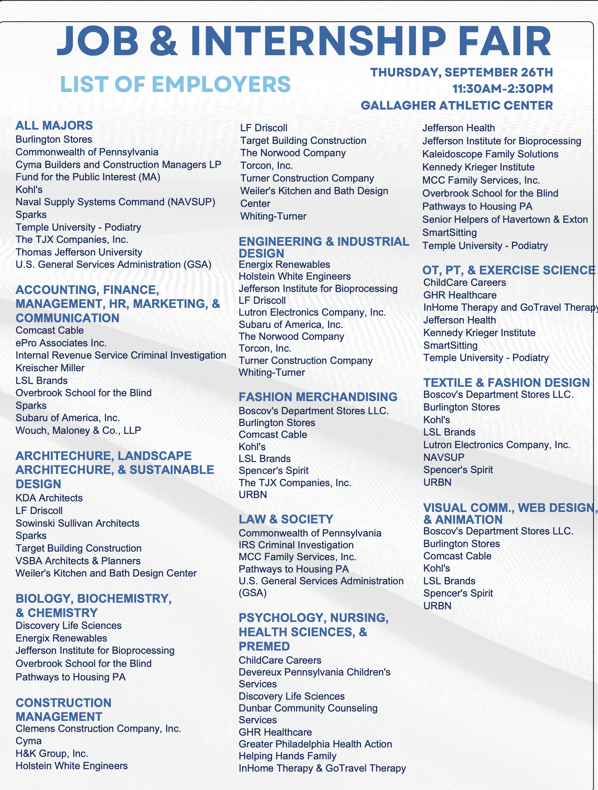

### Music

#### Music, Recording Technology, and Distribution

* Vinyl -> Cassettes -> CDs -> Napster -> iTunes -> Spotify

Record player

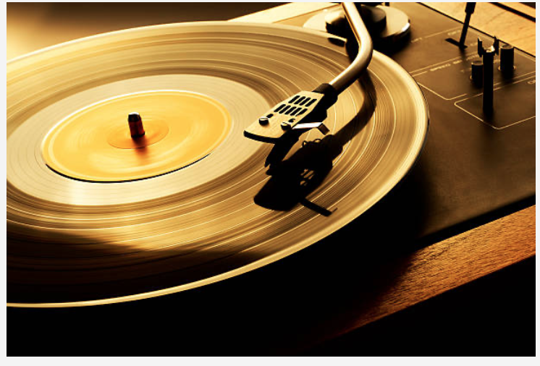

Cassete player and boom box

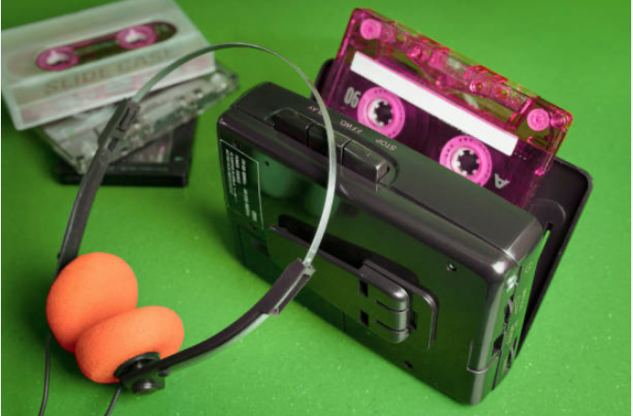

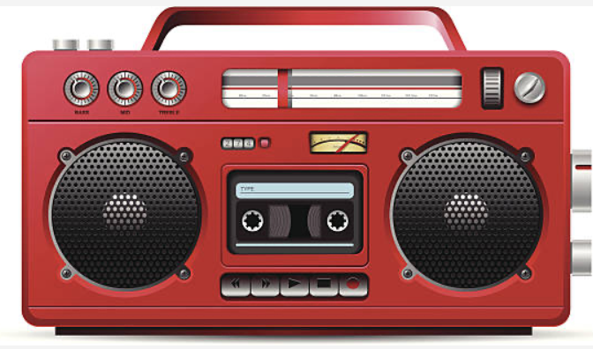

Napster

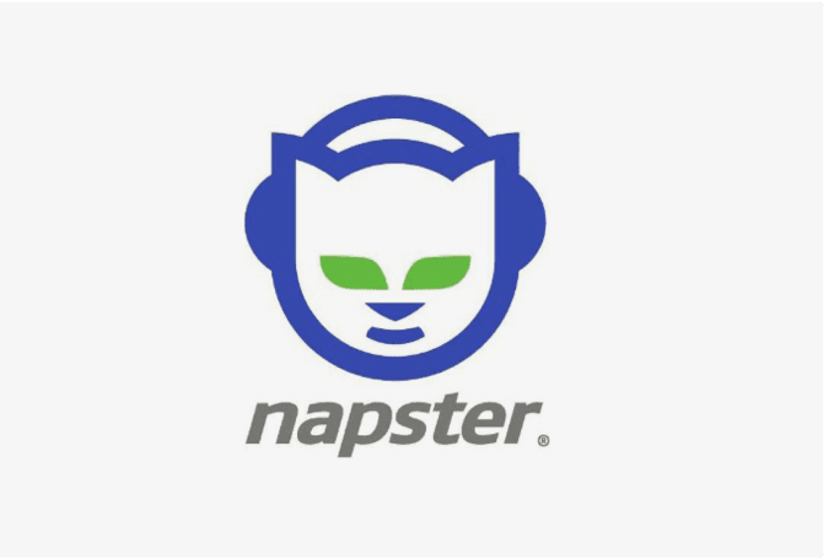

iPod Shuffle

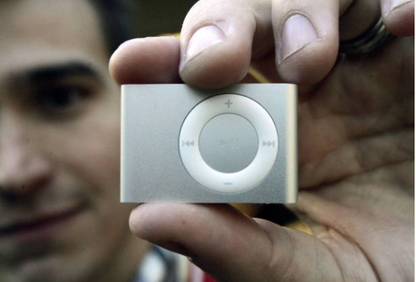

Streaming Services

* From recording studios to streaming
  + Large and Indie Record Companies
    - Universal
    - Sony
    - Warner
    - 65% all music sold by 2020
  + Indie and Vanity Labels
* How did artists make money, and how do they make it today?
* Music, celebrity, and social media

<https://www.youtube.com/watch?v=oYC2BL5J4cY>

- How has social media changed music appreciation?

### Skill of the Week

* Interactive / Data Journalism
* **flourish** <https://flourish.studio>
* interactive charts: <https://flourish.studio/examples/>
* <https://www.youtube.com/watch?v=r6TbcZgYMvY>

### Research Logs



* Communication / media concept?
* Media project type?

# September 30, 2024 (Monday)

### Schedule for Today

* Career Fair Reflections
* Student Media Clips
* Radio
* Talk about Midterm

### Career Fair Reflections

* Did anyone attend? Thoughts?

### Student Media Clips

* Cajun French Language Music from New Orleans (Carly)

<https://youtu.be/AF3CsxICZI4?si=4sHXDha5xeblJBlj>

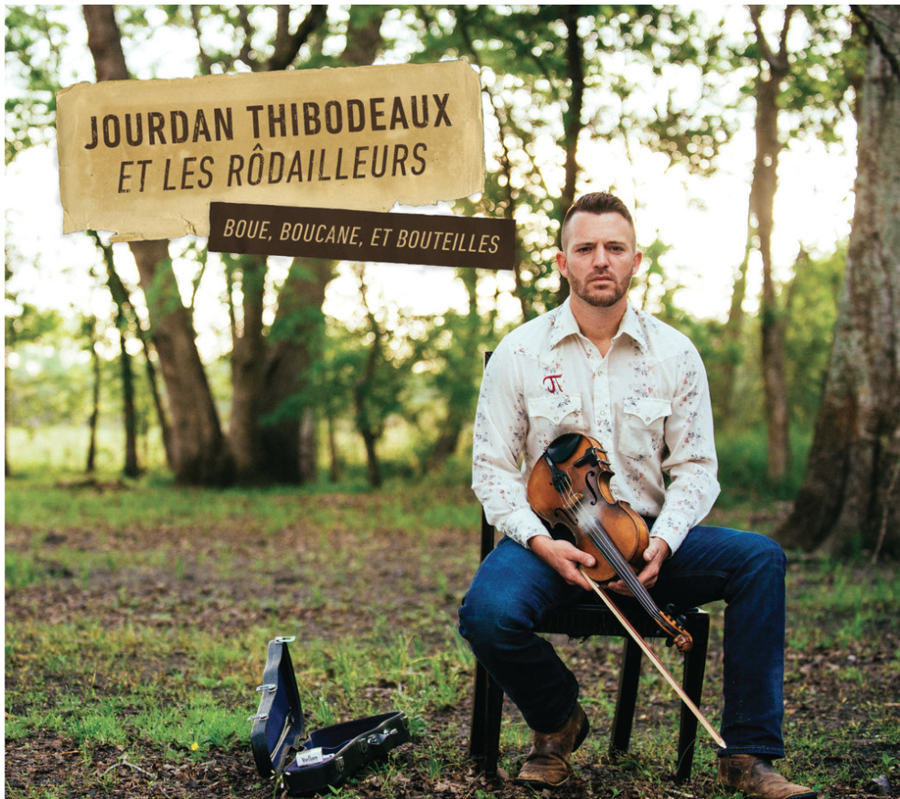

<https://www.valcourrecords.com/cds/jourdan-thibodeaux-et-les-rdailleurs-boue-boucane-et-bouteilles>

* Vinyl in Urban Outfitters (Kyle)

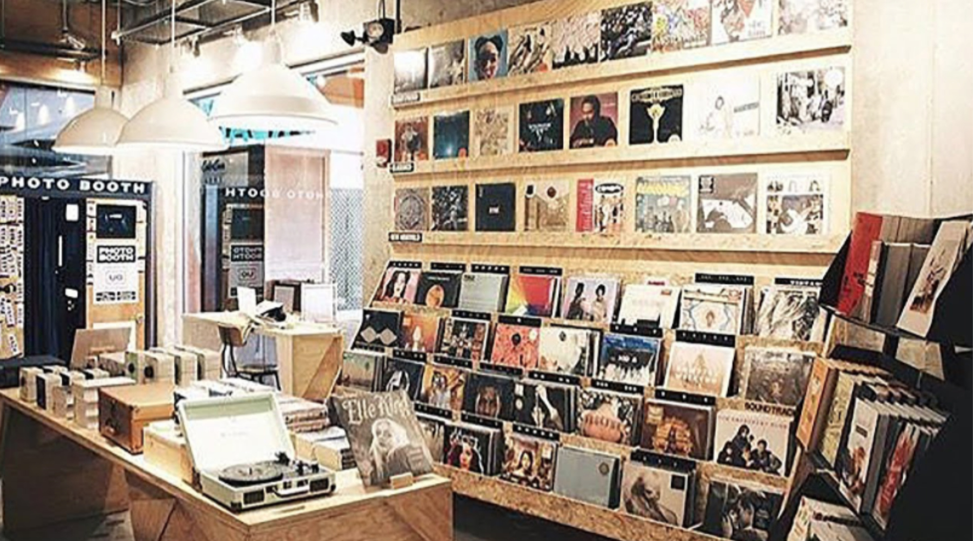

<https://www.urbanoutfitters.com/shop/hybrid/crosley-c100bt-bluetooth-record-player?color=001&type=REGULAR&size=ONE+SIZE&quantity=1>

### Radio

* History

<https://www.youtube.com/watch?v=FexDxf5GLTw>

* Personal v. mass communication

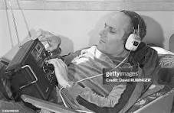

War of the Worlds

<https://www.youtube.com/watch?v=OzC3Fg_rRJM>

* Radio v. Newspaper Coverage
  + Hindenberg Disaster
* In Class Activity: **Find Newspaper Article**
* For example: <https://blog.britishnewspaperarchive.co.uk/2022/04/14/the-hindenburg-disaster-as-told-by-our-newspapers/>
* Listen to Live Radio Coverage:
* <https://www.youtube.com/watch?v=0Ad9tholMEM>
* What’s different about the two mediums?
* Radio Content
  + What types of content have you listened to?
  + Public v. private radio
* Podcasting and Radio

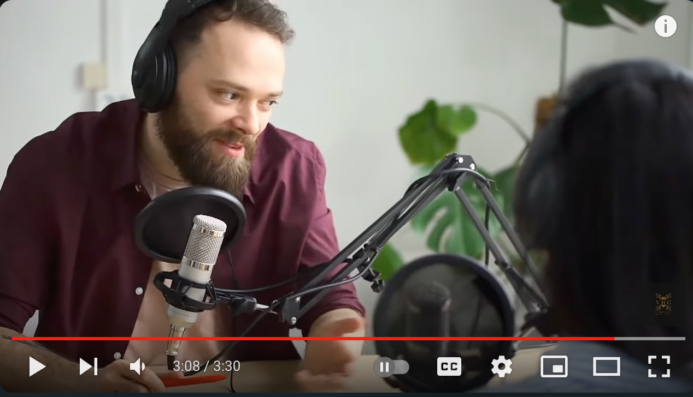

### Talk about Midterm

* Review next Monday
* Midterm in class next Wednesday

# October 2, 2024 (Wednesday)

### Schedule for Today

* Radio (contd.)
* From Radio to Podcasts
* Skill of the Week
* Quizzes and Midterm

### Radio

* Radio ownership: how does it affect content?
* Audience Measurement and Targeted Marketing
  + How does radio compare to other media in helping build brands?
* Nielsen Ratings
* 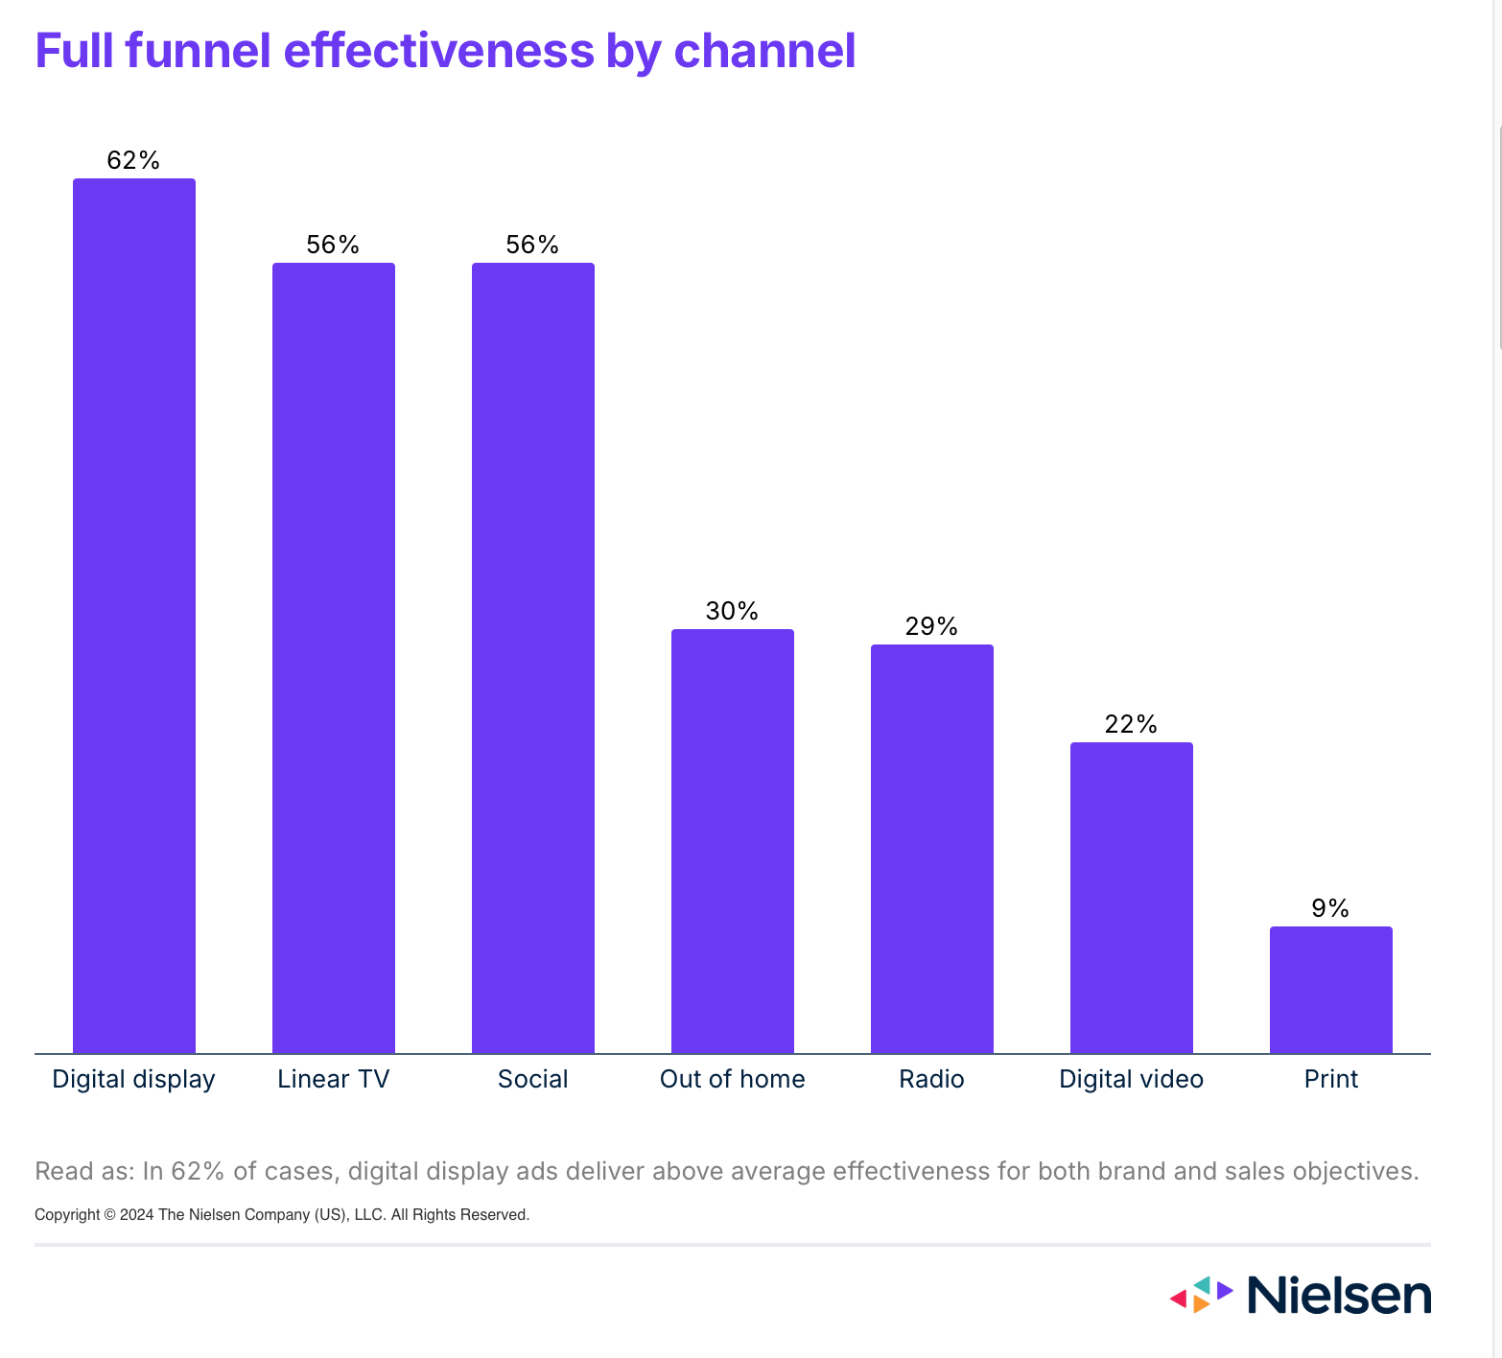
* <https://www.nielsen.com/insights/2024/insights-2024-how-to-plan-with-outcomes-in-mind/>

### From Radio to Podcasts

* *This American Life*

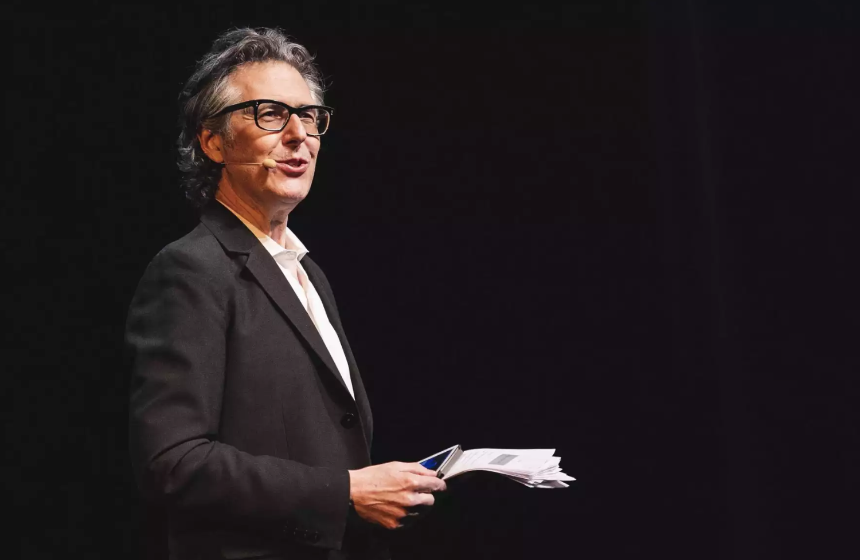

<https://www.kunc.org/news/2023-07-21/ira-glass-talks-about-what-hes-learned-from-decades-of-this-american-life> (0:28 - 03:32)

## Designing a podcast

- How are podcasts different than radio?  
  
- Example: Serial Podcast



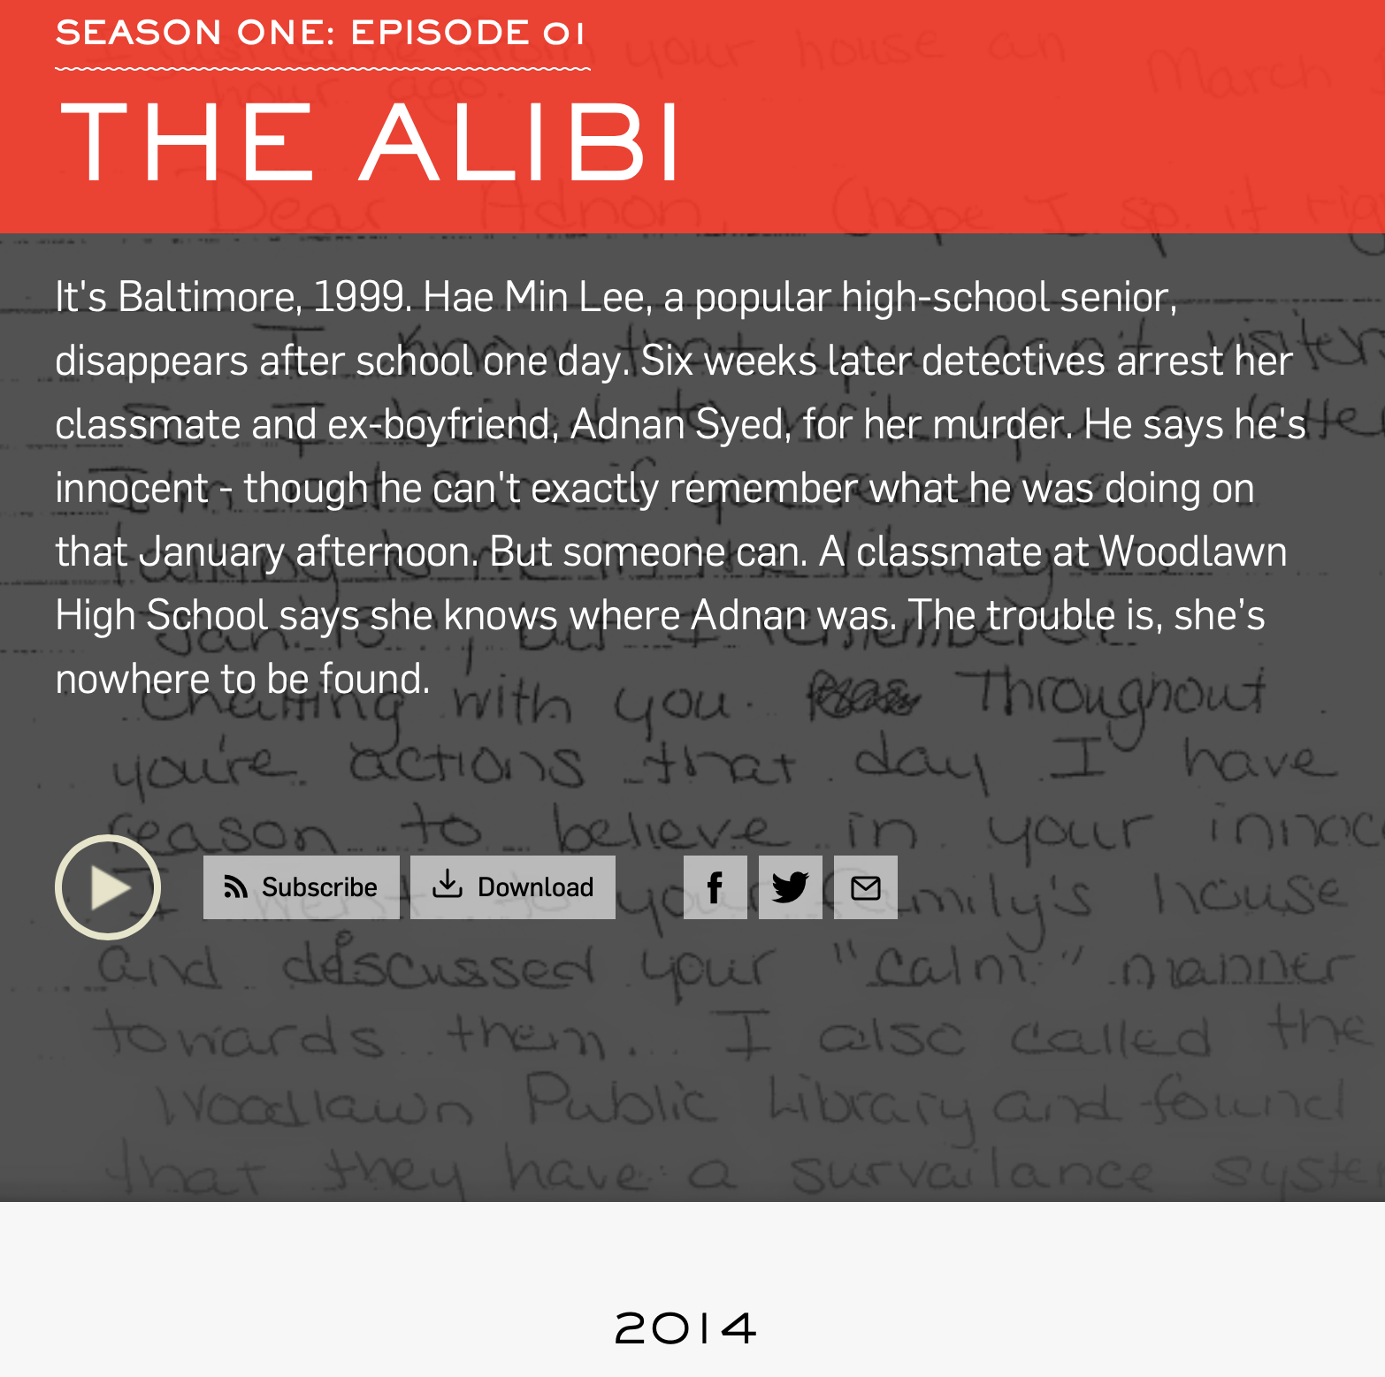

<https://serialpodcast.org/season-one>

- Real-world effect of podcasts

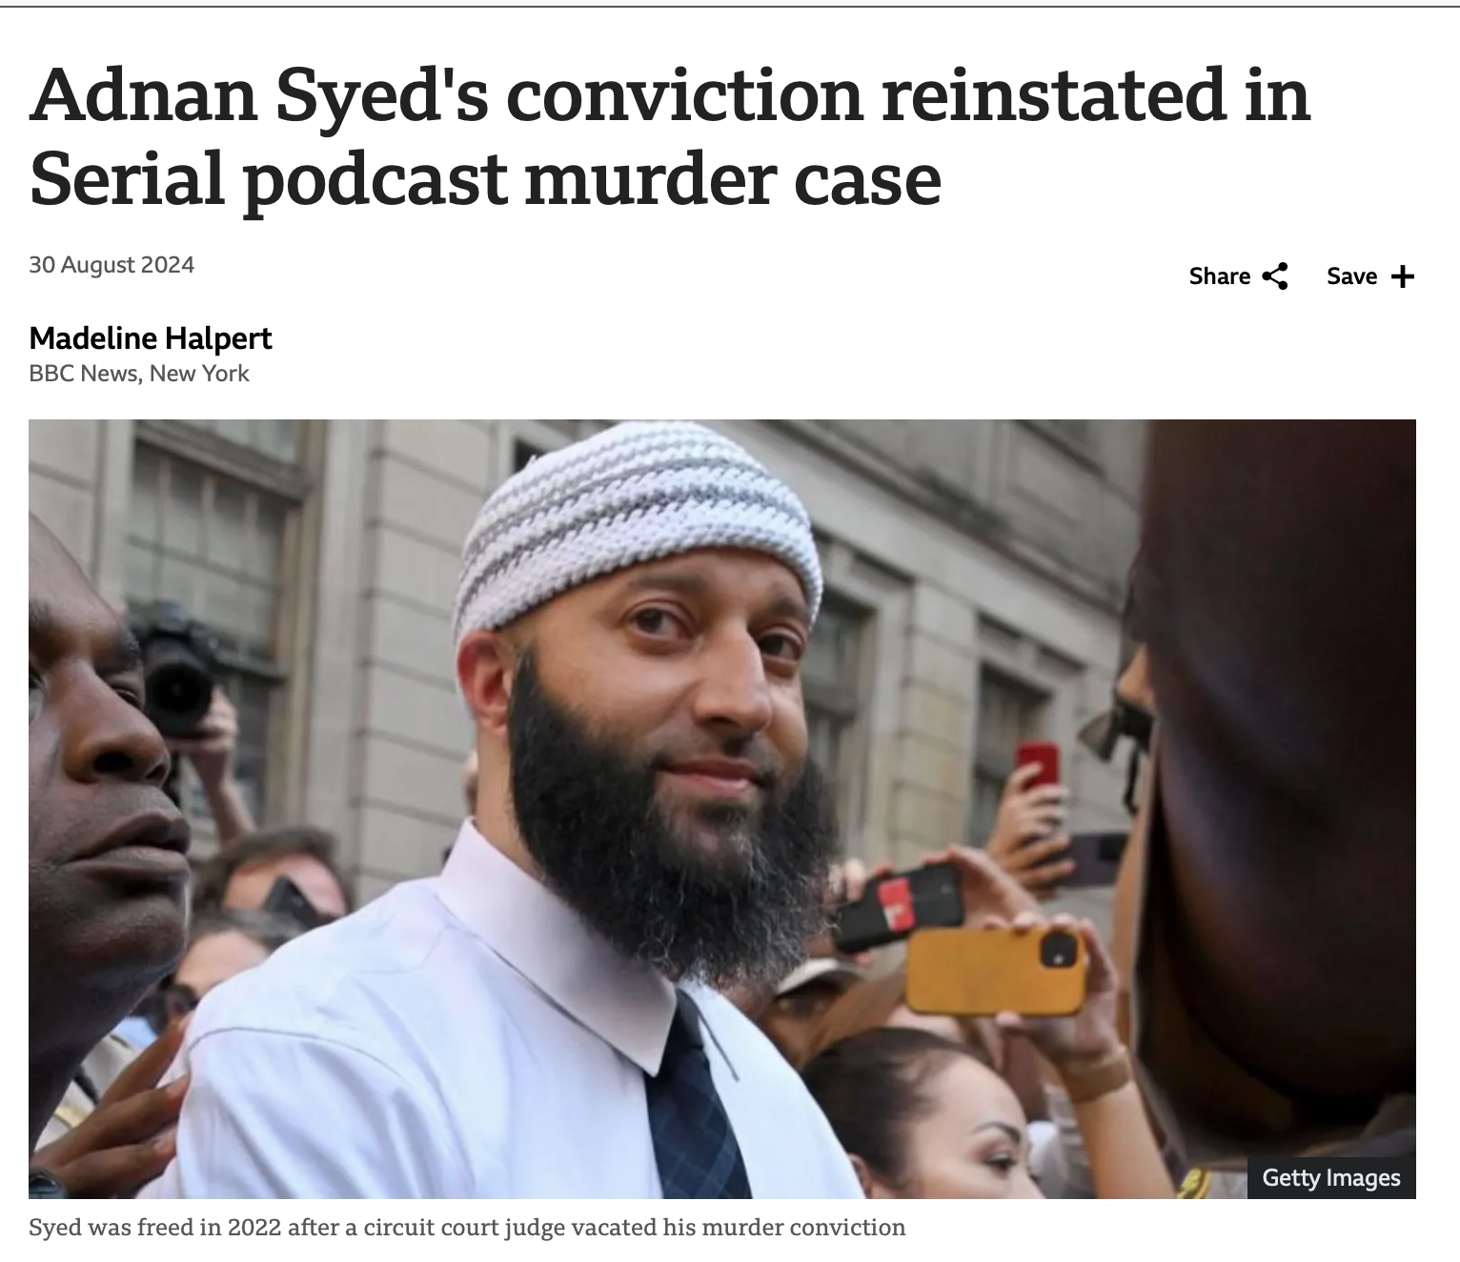

## Podcast Brainstorming

- What would you create?

## Recording a podcast

* Media production studio
* Radio station (WPXU)
  + Kanbar, 3rd floor
  + Corinn Mabry
  + Sofia Corcoran

### Skill of the Week

Creating a website

* Wix <https://www.wix.com>
* 
* GoDaddy <https://www.godaddy.com/websites/website-builder>
* 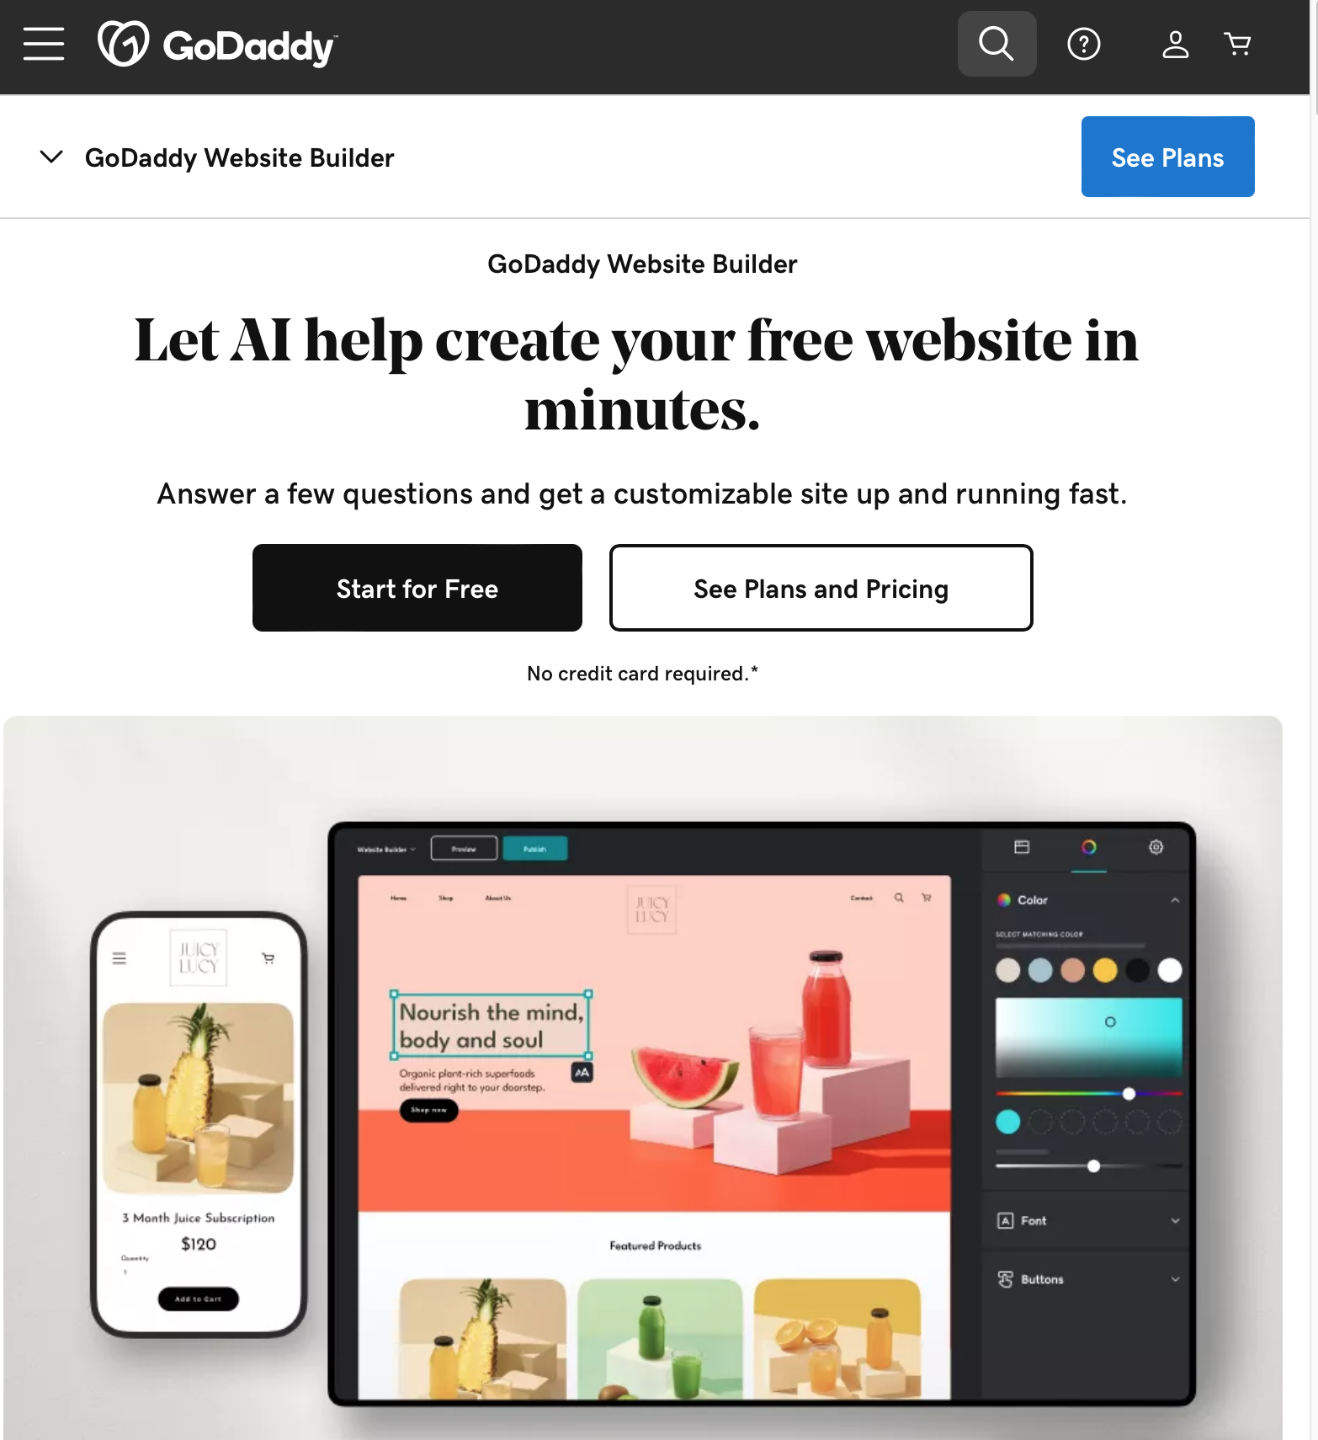
* Wordpress <https://wordpress.com/free/>
* 
* Quarto Pub <https://quartopub.com>
* 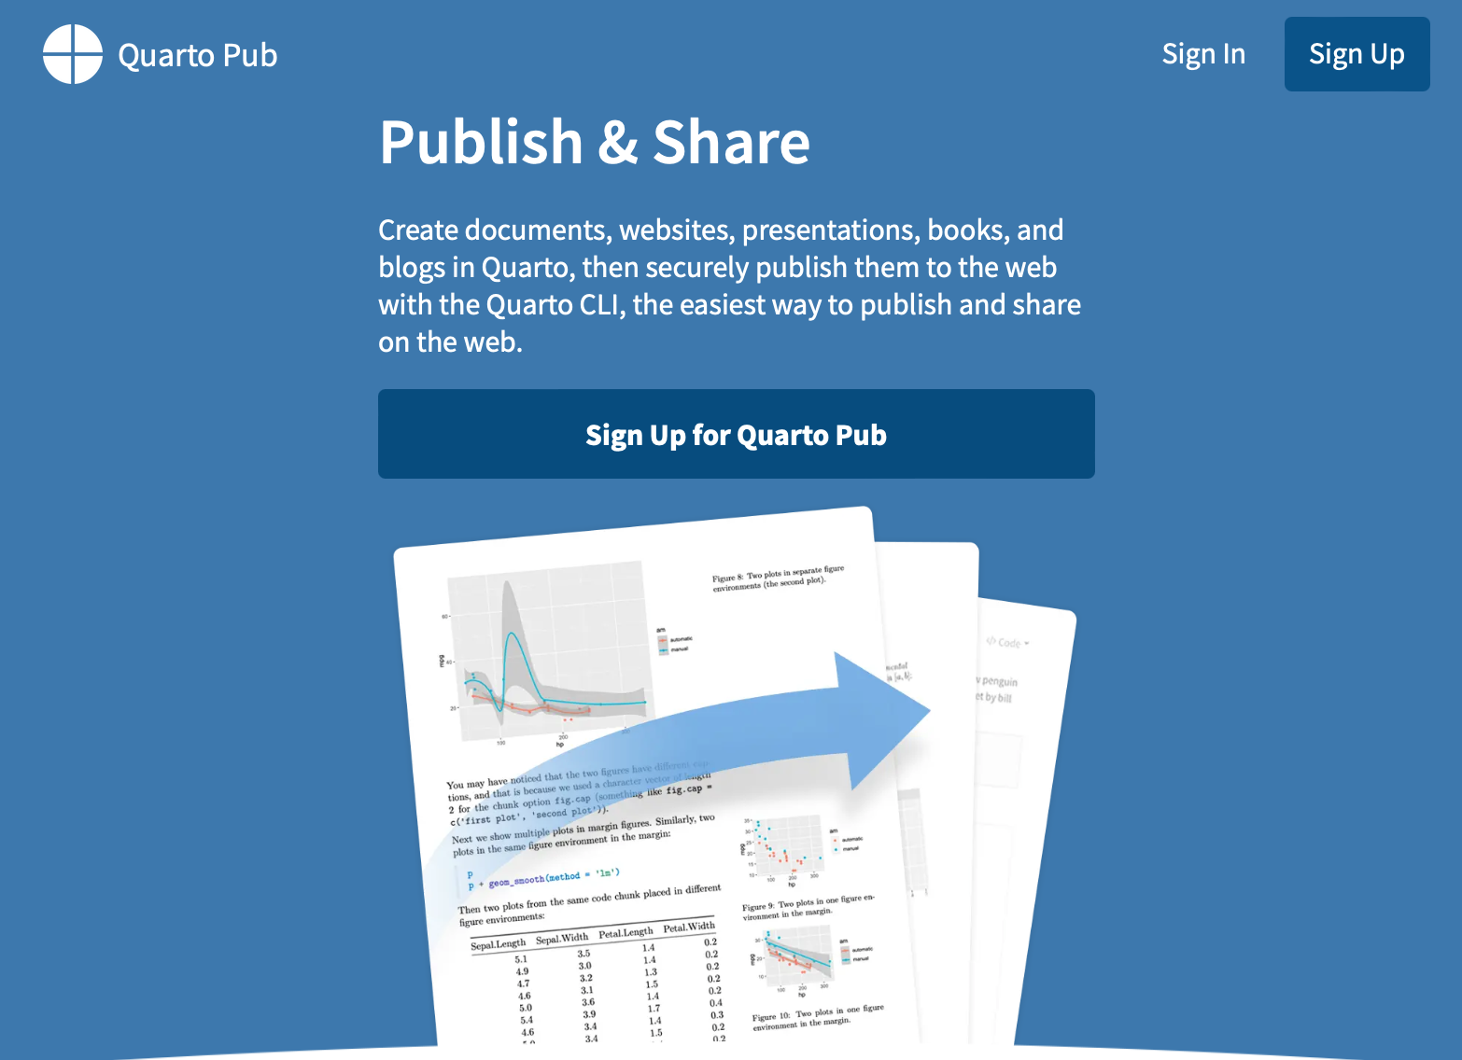

### Quizzes and Midterm

- No quiz this week  
  
- No longer each week - check syllabus  
  
- Midterm review Monday

# October 7, 2024 (Monday)

### Schedule for Today

* Student Media Clips (SMCs)
* Midterm Review